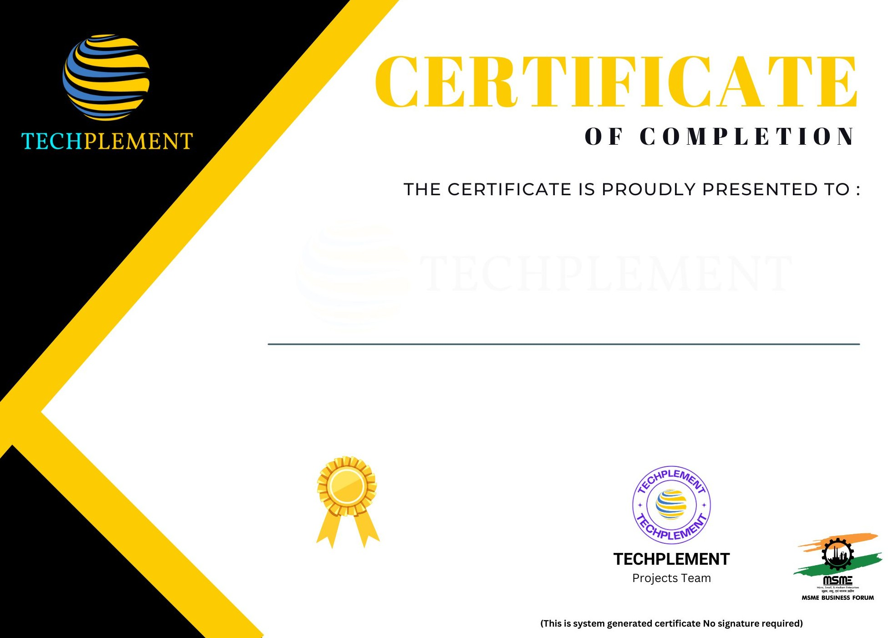

Komal S Kallanagoudar

have completed 1 month internship at TECHPLEMENT as a Python Developer

From 1st May 2024 to 30th May 2024.

Certificate ID : TPPD-052024317